Vision and Scope Document

for

Social Media Sharing System

Version 1.0 approved

Prepared by

|  |  |
| --- | --- |
| Aly Yehia Zakaria Fahmy | 2021170820 |
| Fadi Magdi Zaki Ibrahim | 2021170824 |
| Ahmed Tarek Mohamed Kamal | 2021170804 |
| Karim Fouad Chehab Mohamed | 2021170826 |
| Ahmed Sameh Ahmed Mokhtar | 2021170802 |
| Abdallah Ahmed Shehata Helal | 2021170819 |

Process Impact

April 3, 2024

Table of Contents

Table of Contents ii

Revision History ii

1. Business Requirements 1

1.1. Background 1

1.2. Business Opportunity 1

1.3. Business Objectives 1

1.4. Success Metrics 2

1.5. Vision Statement 2

1.6. Business Risks 2

1.7. Business Assumptions and Dependencies 2

2. Scope and Limitations 3

2.1. Major Features 3

2.2. Scope of Initial and Subsequent Releases 3

2.3. Limitations and Exclusions 4

3. Business Context 4

3.1. Stakeholder Profiles 4

3.2. Project Priorities 5

3.3. Deployment Considerations 5

Revision History

|  |  |  |  |
| --- | --- | --- | --- |
| **Name** | **Date** | **Reason For Changes** | **Version** |
|  | 4/3/24 | Initial Release | 1.0 |
|  | 4/4/24 | Subsequent Release | 1.1 |

# Business Requirements

## Background

With the exponential growth of social media platforms and the increasing importance of digital presence for individuals and organizations alike, the need for efficient and effective social media management tools has become paramount. Traditional manual methods of sharing content across various social media platforms can be time-consuming, error-prone, and inefficient. In response to these challenges, our system has emerged as a solution to streamline the process of content dissemination, enhance visibility, and maximize engagement.

## Business Opportunity

# -Consistency: Using automation, you ensure that a daily quote is posted periodically. This can help retain engagement and draw in followers who value and expect regular material.

# -Time-saving: It can take a while to manually upload daily quotes.

## -Reach: Posting frequently will help you increase your visibility on Instagram and help you reach a wider audience without having to remember to post every day.

## Business Objectives

# BO-1: Brand Awareness: Increase awareness among your target audience. Consistent visibility on Instagram can reinforce brand identity and help potential customers recognize and remember your brand.

# BO-2: Audience Engagement: Engaging your audience with daily quotes can create a community and encourage interaction with your brand.

# BO-3: Audience Growth: Providing valuable and shareable content, such as inspiring quotes, can attract new followers to your Instagram account.

BO-4: **Time Saving** as the system would Increase the average effective work time by 20% and reduce repetitive tasks that the employee would have done.

## Success Metrics

# SM-1: Likes: The number of likes each daily quote receives indicates how well it resonates with your audience.

**SM-2:** **Follower Count**: Tracking the growth in your follower count over time can indicate the effectiveness of your daily quote strategy in attracting new followers.

# SM-3: Comments: Comments show active engagement and may indicate deeper interest or connection with the quote.

# SM-4: Shares: The number of times your quotes are shared can extend your reach to new audiences.

## Vision Statement

Our vision for the automated social media sharing system is to simplify and streamline the process of managing social media content, making it accessible and effective for businesses and individuals alike. We aim to create a user-friendly platform that empowers users to effortlessly share engaging content, connect with their audience, and achieve their marketing goals with ease.

## Business Risks

RI-1: Data security is a major risk due to (personal/business) information, login credentials and user data being vulnerable to cyber threats.

RI-2: The risk of technical issues or server downtime disrupting social media posting schedules and negatively impacting brand visibility and engagement.

RI-3: Lack of taste in the automated system required to make logical changes that satisfy the user.

## Business Assumptions and Dependencies

AS-1: The success of the automated system relies on the assumption that users will actively engage with social media content shared through the platform, leading to increased brand visibility and audience interaction.

AS-2: The automated system assumes compliance with relevant laws, regulations, and social media platform policies, including data protection, copyright, and advertising standards, to mitigate legal risks and ensure ethical use of user data.

DE-1: System depends on the conformance of the content delivery behavior with the constraints stated by the social media platform.

# Scope and Limitations

## Major Features

FE-1: Automation of creation of marketing content.

FE-2: Scheduling the content delivery according to predefined marketing strategy.

FE-3: Generating Reports about followers reacts.

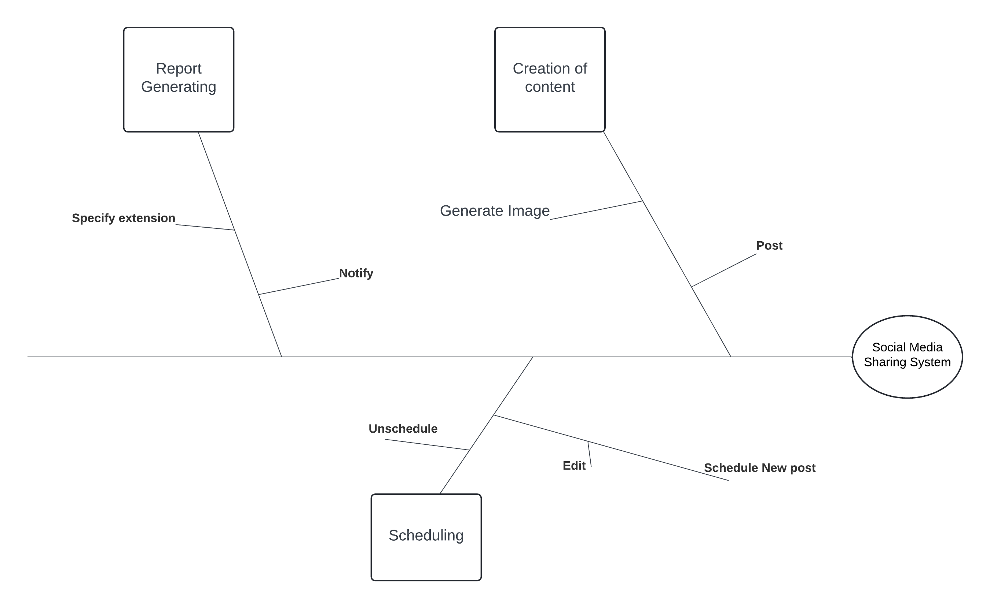

Figure 1. Partial feature tree for the Social Media Sharing System.

## Scope of Initial and Subsequent Releases

|  |  |  |  |
| --- | --- | --- | --- |
| Feature | Phase 1 | Phase 2 | Phase 3 |
| FE-1: Automation of creation of marketing content | Specifying the mechanism of generating the image to be posted with a desired quote. | Chose the appropriate image generating tool. | Start generating the appropriate image. |
| FE-2: Scheduling the content delivery according to predefined marketing strategy. | Building the GUI intended for managing the schedules. | Setting the database to save the scheduled posts. | Connecting Database to the server and acquire scheduled events. |
| FE-3: Generating Reports about followers reacts. | Specified the form of the report and the document extension and how it would be delivered and to whom. | Implementing the functions intended to create the report and establishing the delivery methods. | Fully Implemented. |

## 

## Limitations and Exclusions

LI-1: The automated system may face challenges in adapting content for diverse cultural contexts or regional preferences. Localization efforts, including language translation and cultural sensitivity, may require manual oversight to ensure appropriateness and effectiveness.

LI-2: Automated systems may be limited by constraints imposed by social media platforms' APIs, terms of service, or functionality, hindering the ability to fully leverage platform features or capabilities.

# Business Context

## Stakeholder Profiles

|  |  |  |  |  |
| --- | --- | --- | --- | --- |
| Stakeholder | Major Value | Attitudes | Major Interests | Constraints |
| **Marketing Team** | Developing and executing social media marketing strategies to promote the brand, products, or services. | Continuous reevaluation for the used strategies conforming with the current events. | Maximizing brand visibility, engagement, and conversion through social media channels. | None identified |
| **Social Media Managers** | overseeing social media accounts, monitoring engagement, and responding to audience interactions. | Constant surveillance for the engagement of followers with the delivered content. | Interested in tools that simplify content scheduling, monitoring, and reporting, allowing for efficient management of multiple accounts. | None Identified |
| **Executive Leadership** | Setting strategic direction, allocating resources, and overseeing organizational goals. | Assurance of conformance of publish content with business rules of the company. | Interested in the impact of social media marketing efforts on brand reputation, market share, and overall business performance. | clear visibility into key performance metrics, ROI analysis, and alignment with broader business objectives. |

## Project Priorities

|  |  |  |  |
| --- | --- | --- | --- |
| Dimension | Constraint | Driver | Degree of Freedom |
| Features | All features scheduled for release 1.0 must be fully operational |  |  |
| Quality | 95% of user acceptance tests must pass; all security tests must pass |  |  |
| Schedule |  |  | release 1 planned to be available by end of Q1 of next year, release 2 by end of Q2; overrun of up to 2 weeks acceptable without sponsor review |
| Cost |  |  | budget overrun up to 15% accept able without sponsor review |
| Staff |  | team size is half-time project manager, half-time BA, 3 developers, and 1 tester; additional developer and half-time tester available if necessary |  |

## Deployment Considerations

careful planning is required to determine the optimal deployment strategy, thorough testing and validation procedures should be conducted to verify system functionality, performance, and compatibility with existing IT infrastructure. Clear communication and training initiatives should be implemented to facilitate user adoption and ensure that stakeholders understand how to utilize the system effectively.